
CC-215-L: Database Systems Lab

Faculty of Computing & Information Technology

BS(IT-24)
LAB – 04
The objective of this lab is to:
- Window Functions
- Joins
- Previous SQL Content
COURSE & LAB INSTRUCTOR: Dr. Asif Sohail
LAB TIMING : 90 MINS
TOTAL MARKS : 45
Task 01: [15 marks]
- Display the following.
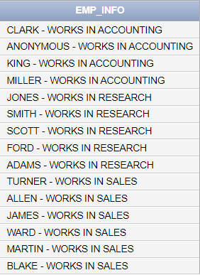
SELECT ENAME || ' - WORKS IN ' || DEPT.DNAME AS EMP_INFO FROM EMP
JOIN DEPT ON EMP.DEPTNO=DEPT.DEPTNO;

- Display the following.
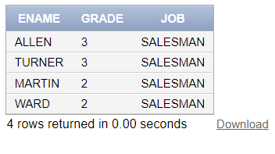
SELECT ENAME, SALGRADE.GRADE,JOB FROM EMP
JOIN SALGRADE ON EMP.SAL BETWEEN SALGRADE.LOSAL AND SALGRADE.HISAL
WHERE JOB LIKE 'SALES%'

- Write an SQL query to display the number of employees working under each manager in department no 10.
SELECT A.EMPNO,A.DEPTNO, COUNT(B.EMPNO) AS COUNT FROM EMP A
JOIN EMP B ON A.EMPNO=B.MGR
WHERE A.DEPTNO=10
GROUP BY A.EMPNO,A.DEPTNO

- Display the employees who earn less than their subordinates.
SELECT
m.ename AS manager_name,
m.sal AS manager_salary,
e.ename AS subordinate_name,
e.sal AS subordinate_salary
FROM emp e
JOIN emp m ON e.mgr = m.empno
WHERE e.sal > m.sal;

- Write the query to find employees who earn more than the average salary of their department.
SELECT EMPNO, ENAME, SAL, DEPTNO,
ROUND(AVG(SAL) OVER (PARTITION BY DEPTNO),2) AS DEPT_AVG,
CASE
WHEN SAL > AVG(SAL) OVER (PARTITION BY DEPTNO) THEN 'Above Average'
WHEN SAL < AVG(SAL) OVER (PARTITION BY DEPTNO) THEN 'Below Average'
ELSE 'Equal to Average'
END AS STATUS
FROM EMP;

- Write an SQL query to retrieve employees whose salaries do not fall within the ranges specified in the salgrade table. Display their grade as “F”.
SELECT DISTINCT EMPNO, ENAME, SAL, DEPTNO,NVL(TO_CHAR(G.GRADE), 'F') AS GRADE
FROM EMP A
LEFT JOIN SALGRADE G ON A.SAL BETWEEN G.LOSAL AND G.HISAL
ORDER BY NVL(TO_CHAR(G.GRADE), 'F')

- Use the window function to find the second highest salary in the whole organization.
SELECT sal, DENSE_RANK() OVER (ORDER BY sal DESC) as salary_rank,CASE
WHEN DENSE_RANK() OVER (ORDER BY sal DESC)= 2 THEN 'SECOND HIGHEST SALARY'
ELSE ''
END AS RANK
FROM EMP

- Display the following.
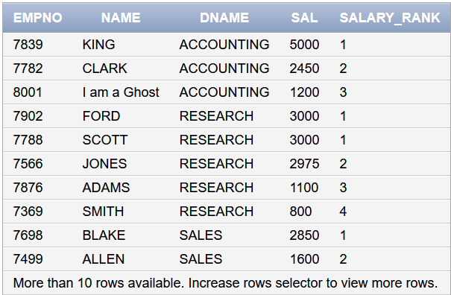
SELECT EMPNO,ENAME AS NAME,DEPT.DNAME , SAL,DENSE_RANK() OVER (PARTITION BY EMP.DEPTNO ORDER BY SAL DESC)AS SAL_RANK FROM EMP
JOIN DEPT ON EMP.DEPTNO=DEPT.DEPTNO

- Get such Employees who earn same as their manager.

SELECT
e.ename AS employee_name,
e.sal AS salary,
m.ename AS manager_name,
m.sal AS manager_salary
FROM emp e
JOIN emp m ON e.mgr = m.empno
WHERE e.sal = m.sal;

- Show the following.
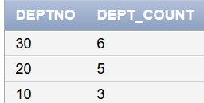
SELECT DEPTNO,COUNT(*) COUNT FROM EMP
GROUP BY DEPTNO
ORDER BY DEPTNO DESC
Task 02: [16 marks]

- Include a query that compares the sal of each employee with the average sal of the employees with same job. The output is ename, job, sal, avg-sal, status.
SELECT
ename,
job,
sal,
ROUND(AVG(sal) OVER (PARTITION BY job), 2) AS avg_sal,
CASE
WHEN sal > AVG(sal) OVER (PARTITION BY job) THEN 'Above Average'
WHEN sal < AVG(sal) OVER (PARTITION BY job) THEN 'Below Average'
ELSE 'Equal to Average'
END AS status
FROM emp
ORDER BY job, sal DESC;

- Display the following.

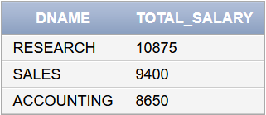
SELECT DISTINCT D.DNAME,SUM(E.SAL) OVER (PARTITION BY E.DEPTNO) AS SUM FROM EMP E
JOIN DEPT D ON E.DEPTNO=D.DEPTNO
ORDER BY SUM(E.SAL) OVER (PARTITION BY E.DEPTNO) DESC

- List the jobs in all the departments as follows.
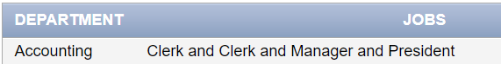
SELECT
D.DNAME AS DEPARTMENT,
LISTAGG(E.JOB, ' and ') WITHIN GROUP (ORDER BY E.JOB) AS JOBS
FROM
EMP E
JOIN
DEPT D ON E.DEPTNO = D.DEPTNO
GROUP BY
D.DNAME;

- Display Jobs with total number of hirings.
SELECT
JOB,
COUNT(*) AS TOTAL_HIRINGS
FROM
EMP
GROUP BY
JOB
ORDER BY
TOTAL_HIRINGS DESC;

- List the employees based on the number of vowels in their names, with the employee having the highest number of vowels ranked first.
SELECT
ENAME,
(LENGTH(ENAME) - LENGTH(
REPLACE(
REPLACE(
REPLACE(
REPLACE(
REPLACE(UPPER(ENAME), 'A', ''),
'E', ''),
'I', ''),
'O', ''),
'U', '')
)) AS VOWEL_COUNT,
RANK() OVER (ORDER BY
(LENGTH(ENAME) - LENGTH(
REPLACE(
REPLACE(
REPLACE(
REPLACE(
REPLACE(UPPER(ENAME), 'A', ''),
'E', ''),
'I', ''),
'O', ''),
'U', '')
)) DESC
) AS RANK_BY_VOWELS
FROM
EMP
ORDER BY
VOWEL_COUNT DESC;

- For each department, display the Department Name along with highest salary, lowest salary, total salary, and average salary, only if the department has at least 3 employees.

SELECT
D.DEPTNO,
D.DNAME,
MAX(E.SAL) AS HIGHEST_SALARY,
MIN(E.SAL) AS LOWEST_SALARY,
SUM(E.SAL) AS TOTAL_SALARY,
ROUND(AVG(E.SAL), 2) AS AVG_SALARY
FROM
EMP E
JOIN
DEPT D ON E.DEPTNO = D.DEPTNO
GROUP BY
D.DEPTNO, D.DNAME
HAVING
COUNT(E.EMPNO) >= 3
ORDER BY
AVG_SALARY DESC;

- Display the employees along with the median hire dates for their respective jobs.
SELECT
JOB,
MEDIAN(HIREDATE) AS MEDIAN_HIREDATE
FROM
EMP
GROUP BY
JOB;
- Display each employee (ename) and their manager’s salary difference using a self join and window function.
Also, find each employee’s next employee salary using LEAD().
SELECT
E.ENAME AS EMPLOYEE,
M.ENAME AS MANAGER,
E.SAL AS EMP_SAL,
M.SAL AS MGR_SAL,
(E.SAL - M.SAL) AS SAL_DIFF,
LEAD(E.SAL) OVER (ORDER BY E.SAL DESC) AS NEXT_EMP_SAL
FROM
EMP E
LEFT JOIN
EMP M ON E.MGR = M.EMPNO
ORDER BY
E.SAL DESC;

- Find the employee with the third highest salary in each department.
SELECT *
FROM (
SELECT
EMPNO,
ENAME,
DEPTNO,
SAL,
DENSE_RANK() OVER (PARTITION BY DEPTNO ORDER BY SAL DESC) AS RANK_SAL
FROM
EMP
)
WHERE RANK_SAL = 3;

- Summarize a report that displays each job along with all the associated departments and the total salary earned for each job. Additionally, provide the reverse view showing all departments along with their respective jobs and the total salary earned in each department.

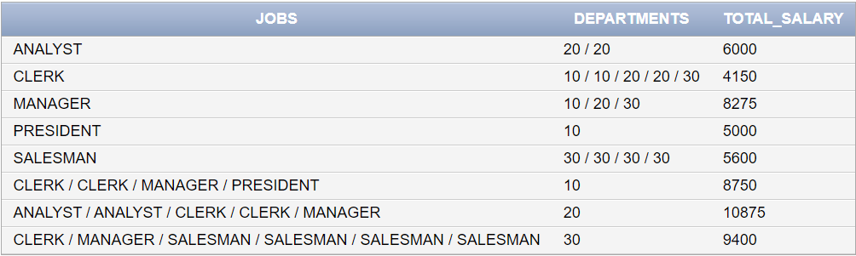

SELECT
JOB AS JOBS,
LISTAGG(DEPTNO, ' / ') WITHIN GROUP (ORDER BY DEPTNO) AS DEPARTMENTS,
SUM(SAL) AS TOTAL_SALARY
FROM
EMP
GROUP BY
JOB

UNION ALL

SELECT
LISTAGG(JOB, ' / ') WITHIN GROUP (ORDER BY JOB) AS JOBS,
TO_CHAR(DEPTNO) AS DEPARTMENTS,
SUM(SAL) AS TOTAL_SALARY
FROM
EMP
GROUP BY
DEPTNO
ORDER BY
TOTAL_SALARY ;

Task 03: [9 marks]
- Write a query that lists departments and, for each department, concatenates the names of employees who have salaries above the department's average salary. The concatenated list should be sorted by the reverse alphabetical order of the employee names, and all names should be converted to lowercase. If there are no employees with salaries above the average for that department, display "NO HIGH SALARY EMPLOYEES" for that department.
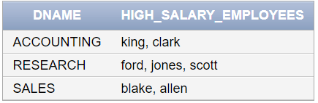
SELECT d.deptno,
NVL(
LISTAGG(LOWER(e.ename), ' / ')
WITHIN GROUP (ORDER BY e.ename DESC),
'no high salary employees'
) AS high_salary_employees
FROM emp e
JOIN dept d ON e.deptno = d.deptno
WHERE e.sal > (SELECT AVG(sal) FROM emp WHERE deptno = e.deptno)
GROUP BY d.deptno
ORDER BY d.deptno;

- Write an SQL query to display each employee's name, but only show the character in the name that corresponds to the number of employees in that employee's department. If the name is shorter than the employee count, display the first character. Group the results by department and list the names in a concatenated format for each department.
SELECT deptno,
LISTAGG(SUBSTR(ename,
CASE
WHEN LENGTH(ename) >= (SELECT COUNT(*) FROM emp e2 WHERE e2.deptno = e1.deptno)
THEN (SELECT COUNT(*) FROM emp e2 WHERE e2.deptno = e1.deptno)
ELSE 1
END,
1),
' / ')
WITHIN GROUP (ORDER BY ename) AS dept_characters
FROM emp e1
GROUP BY deptno
ORDER BY deptno;

- Display the following. Use of CASE AND DECODE not allowed for last column.

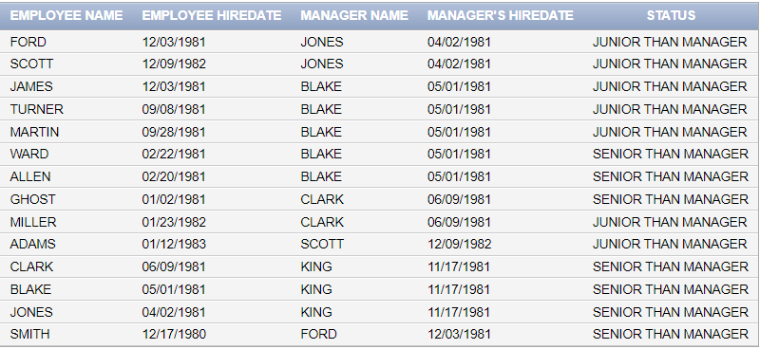
SELECT
e.ename AS "EMPLOYEE NAME",
TO_CHAR(e.hiredate, 'MM/DD/YYYY') AS "EMPLOYEE HIREDATE",
m.ename AS "MANAGER NAME",
TO_CHAR(m.hiredate, 'MM/DD/YYYY') AS "MANAGER'S HIREDATE",
SUBSTR(' JUNIOR SENIOR',SIGN(E.HIREDATE-M.HIREDATE)*6,6) || ' than Manager' as SENIORITY
FROM emp e
JOIN emp m
ON e.mgr = m.empno
ORDER BY e.ename;

Task 04: [5 marks]
VIVA VOCE

